LAB REPORT

EXPERIMENT 1: STUDENT GRADE DISTRIBUTION USING PIE AND BAR CHARTS
Aim
To write a Python program using Matplotlib to represent the percentage distribution of students across grades using a pie chart, compare the number of students in each grade using a bar chart, identify the maximum and minimum grade counts, and calculate the combined percentage of students who secured grades A and S.
Algorithm
- Store the grades F, E, D, C, B, A, and S and their corresponding student counts in lists.
- Calculate the total number of students and the percentage for each grade.
- Draw a pie chart with grade labels and percentage values; add a title and legend.
- Draw a bar chart to compare student counts for each grade.
- Label the X-axis as Grades and the Y-axis as Number of Students, and display each count above its bar.
- Find the maximum and minimum student counts and the corresponding grades.
- Calculate the combined number and percentage of students who secured grades A and S.
- Display the charts and print the calculated results.
Program
import matplotlib.pyplot as plt

grades = ['F', 'E', 'D', 'C', 'B', 'A', 'S']
students = [3, 4, 5, 8, 9, 7, 4]
total_students = sum(students)
percentages = [(n / total_students) * 100 for n in students]

# Pie chart
plt.figure(figsize=(8, 6))
plt.pie(students, labels=grades, autopct='%1.1f%%', startangle=90)
plt.title('Percentage Distribution of Students by Grade')
plt.legend(grades, title='Grades', loc='best')
plt.show()

# Bar chart
plt.figure(figsize=(8, 6))
bars = plt.bar(grades, students, color='skyblue', edgecolor='black')
plt.title('Number of Students in Each Grade')
plt.xlabel('Grades')
plt.ylabel('Number of Students')
for bar in bars:
height = bar.get_height()
plt.text(bar.get_x() + bar.get_width()/2, height, str(int(height)),
ha='center', va='bottom')
plt.legend(['Number of Students'])
plt.show()

# Maximum and minimum
max_students = max(students)
min_students = min(students)
max_grades = [grades[i] for i, n in enumerate(students) if n == max_students]
min_grades = [grades[i] for i, n in enumerate(students) if n == min_students]

print("Total number of students:", total_students)
print("Grade(s) with maximum students:", max_grades)
print("Maximum number of students:", max_students)
print("Grade(s) with minimum students:", min_grades)
print("Minimum number of students:", min_students)

# Combined percentage of grades A and S
a_s_students = students[grades.index('A')] + students[grades.index('S')]
a_s_percentage = (a_s_students / total_students) * 100
print("Students who secured grades A and S:", a_s_students)
print("Combined percentage of grades A and S:",
round(a_s_percentage, 2), "%")
Output
The program generates a pie chart showing the percentage distribution of students by grade and a bar chart comparing the number of students in each grade. The following screenshots show the output produced in Google Colab.
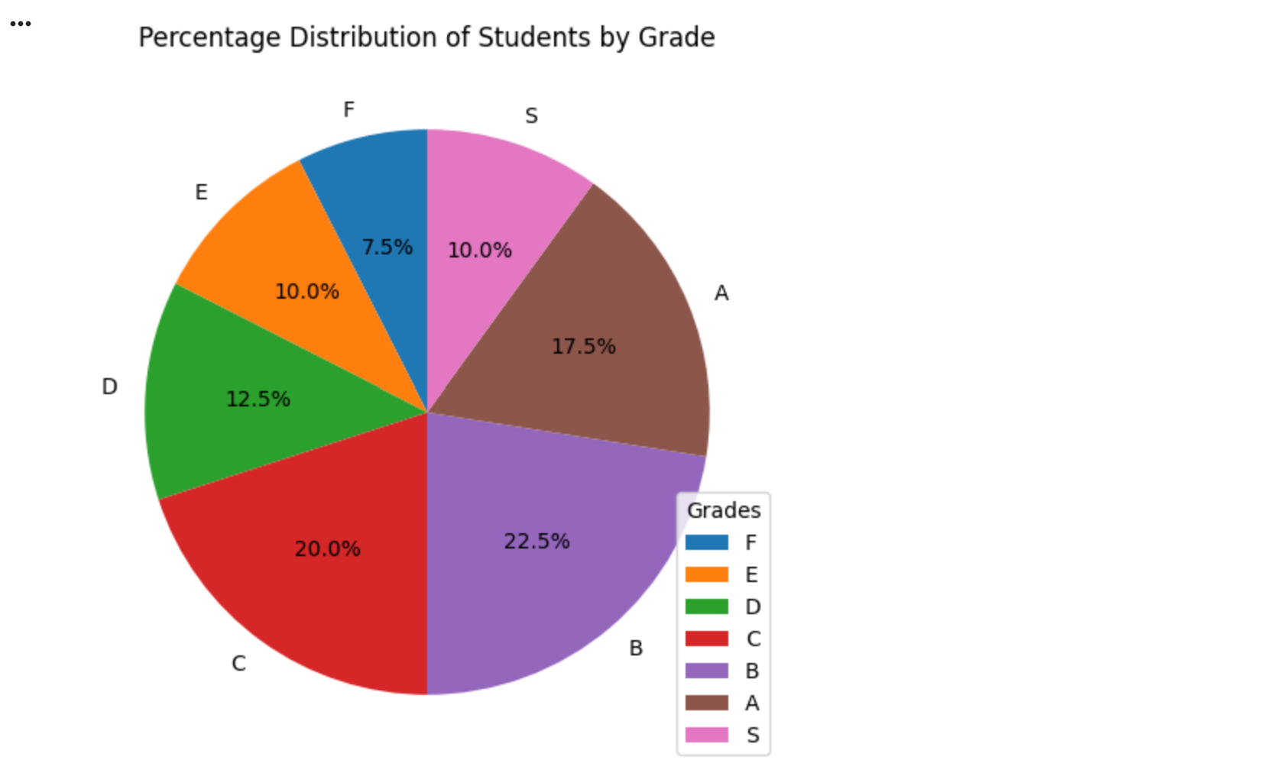

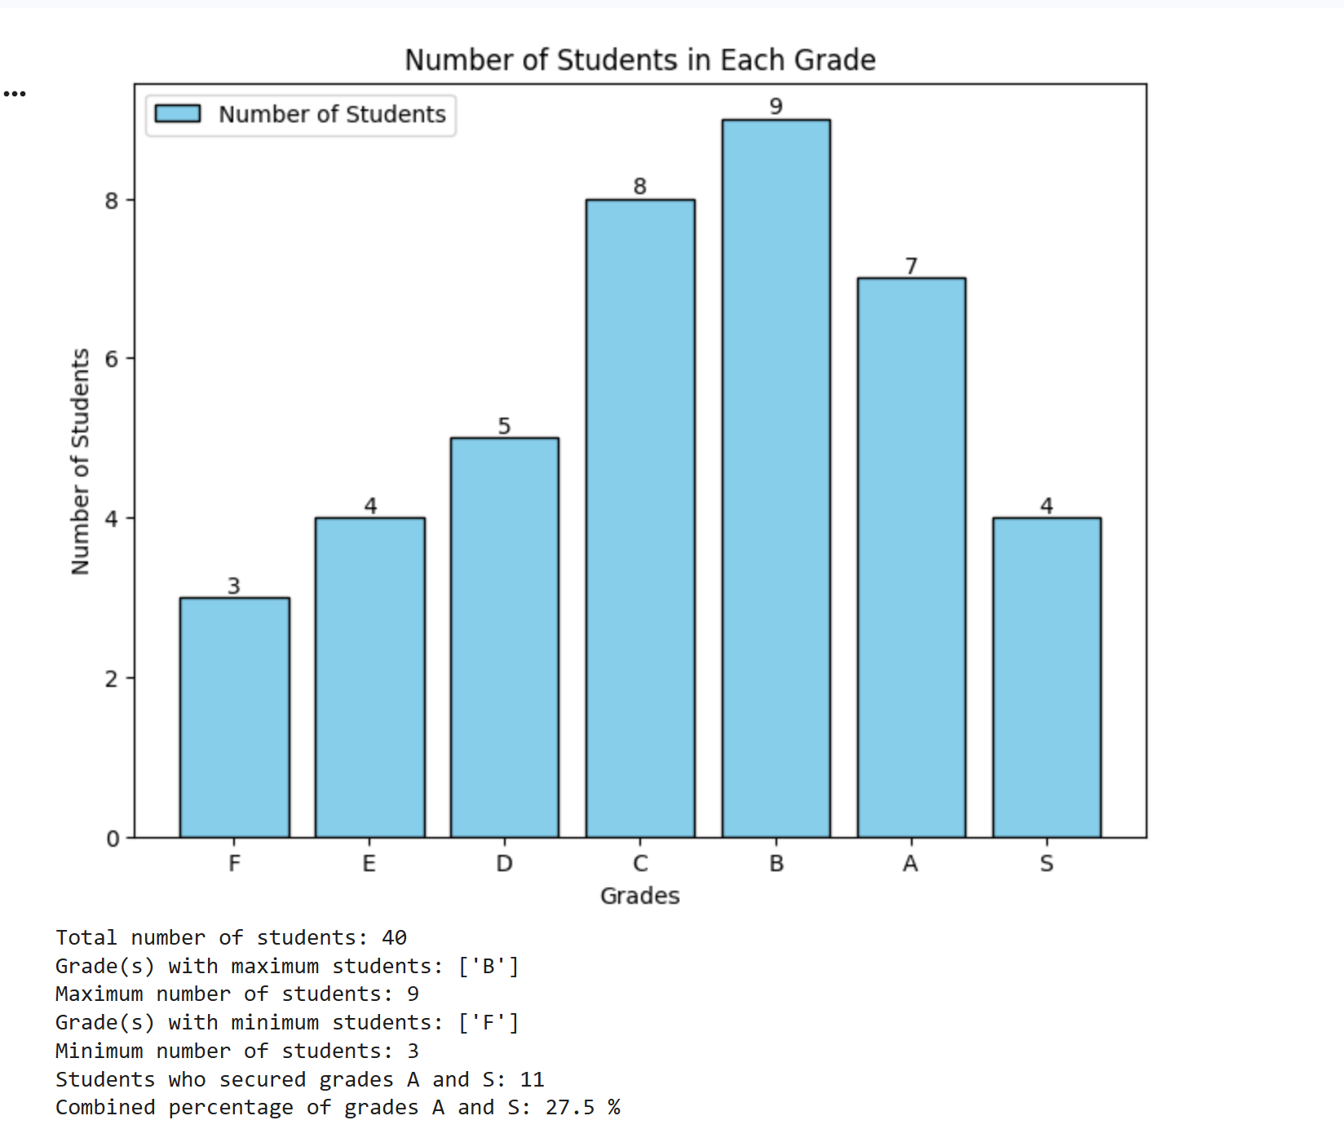
Result
The pie chart and bar chart were generated successfully. Grade B had the maximum number of students (9), while grade F had the minimum number (3). A total of 11 students secured grades A and S combined, representing 27.5% of the class.

EXPERIMENT 2: SEMANTIC NETWORK USING NETWORKX
Aim
To represent concepts and their labeled relationships as a directed semantic network using Python and the NetworkX library, and to display the relationships and graphically visualize the network.
Algorithm
- Import the NetworkX and Matplotlib libraries.
- Create a directed graph using nx.DiGraph().
- Add edges between Dog and Mammal, Mammal and Animal, and Dog and Tommy, assigning a relationship label to each edge.
- Display each relationship by iterating through the graph edges and printing the source, relation, and target.
- Calculate node positions and draw the directed graph with labeled nodes and arrows.
- Display the relationship labels on the edges, add a title, and show the graph.
Program
import networkx as nx
import matplotlib.pyplot as plt

# Create a directed semantic network
G = nx.DiGraph()
G.add_edge("Dog", "Mammal", relation="is-a")
G.add_edge("Mammal", "Animal", relation="is-a")
G.add_edge("Dog", "Tommy", relation="has-instance")

print("Semantic Network Relationships:")
for source, target, data in G.edges(data=True):
print(source, "--", data["relation"], "-->", target)

# Draw the semantic network
pos = nx.spring_layout(G, seed=42)
nx.draw(G, pos, with_labels=True, node_color="lightblue",
node_size=2500, font_size=12, font_weight="bold",
arrows=True, arrowsize=20)
edge_labels = nx.get_edge_attributes(G, "relation")
nx.draw_networkx_edge_labels(
G, pos, edge_labels=edge_labels, font_color="red")
plt.title("Semantic Network")
plt.axis("off")
plt.show()
Output
The program prints the three semantic relationships and displays a directed graph. The screenshot below shows the output produced in Google Colab.
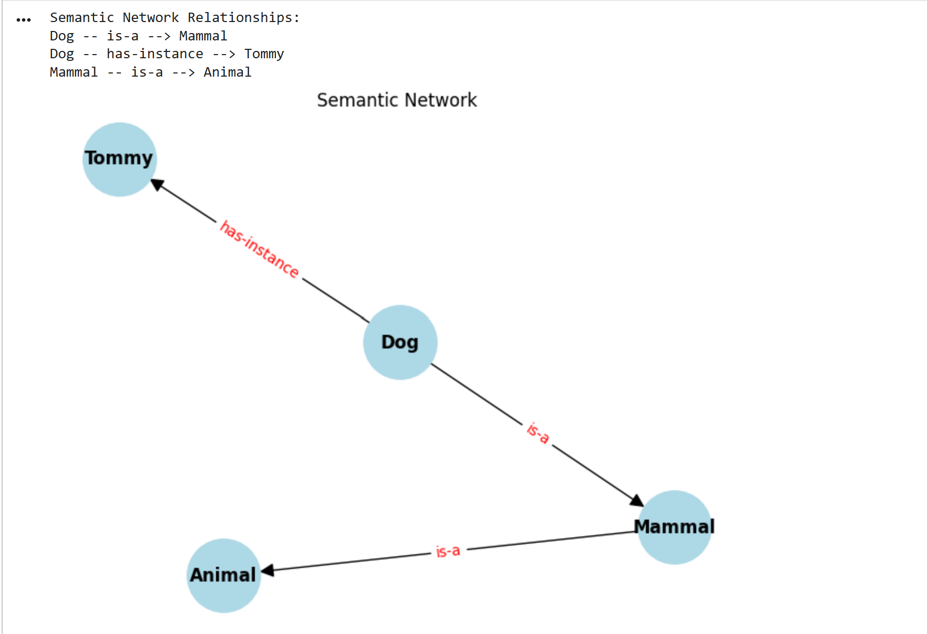
Expected Text Output
Semantic Network Relationships:
Dog -- is-a --> Mammal
Dog -- has-instance --> Tommy
Mammal -- is-a --> Animal
Result
The semantic network was successfully represented using NetworkX. Dog, Mammal, Animal, and Tommy were represented as nodes, while the relationships “is-a” and “has-instance” were represented as labeled directed edges. The relationships were printed and the network was visualized.

EXPERIMENT-3:FRAME-BASED KNOWLEDGE REPRESENTATION
Aim
To represent an object using a frame containing slots and their corresponding values, and to display the frame using a Python dictionary.
Algorithm
- Create a Python dictionary named vehicle to represent the vehicle frame.
- Use keys such as class, brand, fuel_type, wheels, and color as the slots.
- Assign an appropriate value to each slot.
- Display the heading “Vehicle Frame”.
- Use a for loop to iterate through the dictionary items.
- Print each slot and its corresponding value.
Program
# Frame-Based Knowledge Representation
# Create a dictionary representing a vehicle frame
vehicle = {
"class": "Vehicle",
"brand": "Toyota",
"fuel_type": "Petrol",
"wheels": 4,
"color": "White"
}
# Display the frame and its slot values
print("Vehicle Frame")
for slot, value in vehicle.items():
print(slot, ":", value)
Output
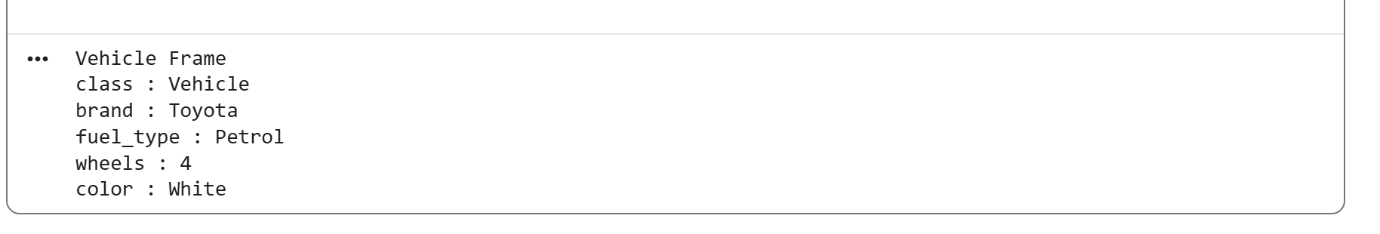
Result
The vehicle was successfully represented using frame-based knowledge representation in Python. A dictionary was used to store the slots and their corresponding values, and a for loop was used to display the frame.

